**Factory Pattern**

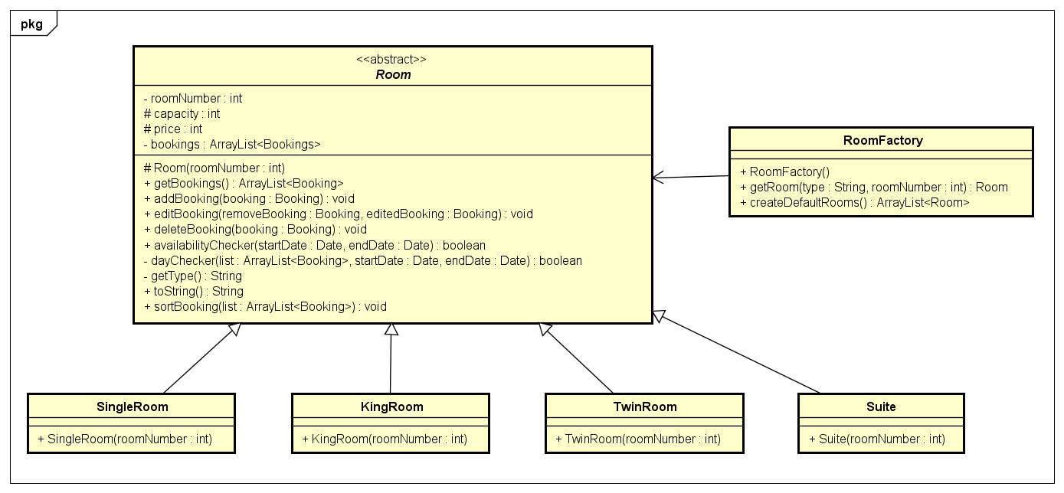

Factory design pattern provides one of the best ways to create objects with the creation of the pure fabrication object called RoomFactory that handles all the room creations. RoomFactory object has several advantages:

* Separate the responsibility of complex creation of Room objects
* Hide potentially complex creation logic
* 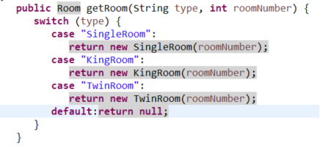Allow object caching or recycling